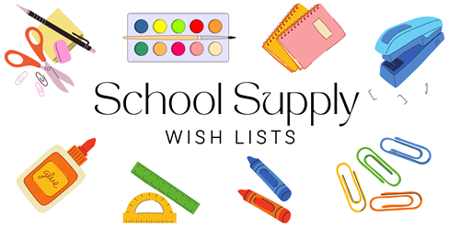

**SPECIAL PROGRAMS**

**24/25**

2 BOXES OF TISSUES

2 ROLLS OF PAPER TOWELS

2 TUBS OF LYSOL WIPES

2 YELLOW HIGHLIGHTER MARKERS

1 BOX OF TRI-WRITE PENCILS

1 PACK OF LARGE CRAYOLA CRAYONS (8ct)

4 DRY ERASE MARKERS (ANY COLOR)

4 GLUE STICKS (LARGE)

6 2 POCKET / 3 PRONG FOLDERS (ANY COLORS)

1 PAIR OVER THE HEAD HEADPHONES (FOR TECHNOLOGY USE)

2 PACKAGES OF BABY WIPES

2 REAMS OF COPY PAPER

5 COMPOSITION NOTEBOOKS (ANY COLORS)

**GRADES 3, 4 & 5 ONLY:**

1 MUSIC RECORDER FOR MUSIC CLASS